**EXP 2: DUAL LED CHASER LIGHTS**

**CIRCUIT DIAGRAM:**

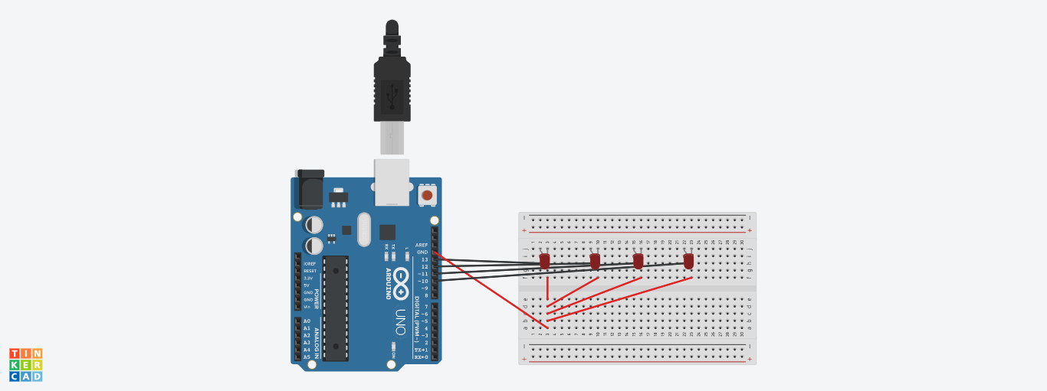

**THEORY:**

In this experiment we connected 4 LEDS to breadboard, the 4 LEDS were connected to the arduino separately but they have a common wire connected to ground, that was for connection. The concept used in coding is that we put 2 leds at high and 1 at low in one condition, then delay. Like firstly LEDS at 10 and 11 will be at high and 13 at low, after delay 11 and 12 at high and 10 at low.

**PROBLEMS AND TROUBLESHOOTING:**

There are few problems e when connecting the wires and led on breadboard, if you are not clear with the working of bread board then it would be really difficult to connect. Then there is coding, you just need to know the basic coding, then it won’t be that difficult.

**PRECAUTIONS:**

The connections on breadboard should be done carefully, otherwise the LED might not blink. If there is any semantic mistake in the code then the LED won’t glow too, so it’s better to code with free and open mind.

**LEARNING OUTCOMES:**

In this experiment we learned how to glow different LEDS at different time, the connection and coding for it.